**EXPERT SYSTEM PROJECT**

The rules are made on the basis of classification as specified in the diagram below and the features that the groups of animal possess to answer the query. Here Var_animal is the variable which is passed in the rule.

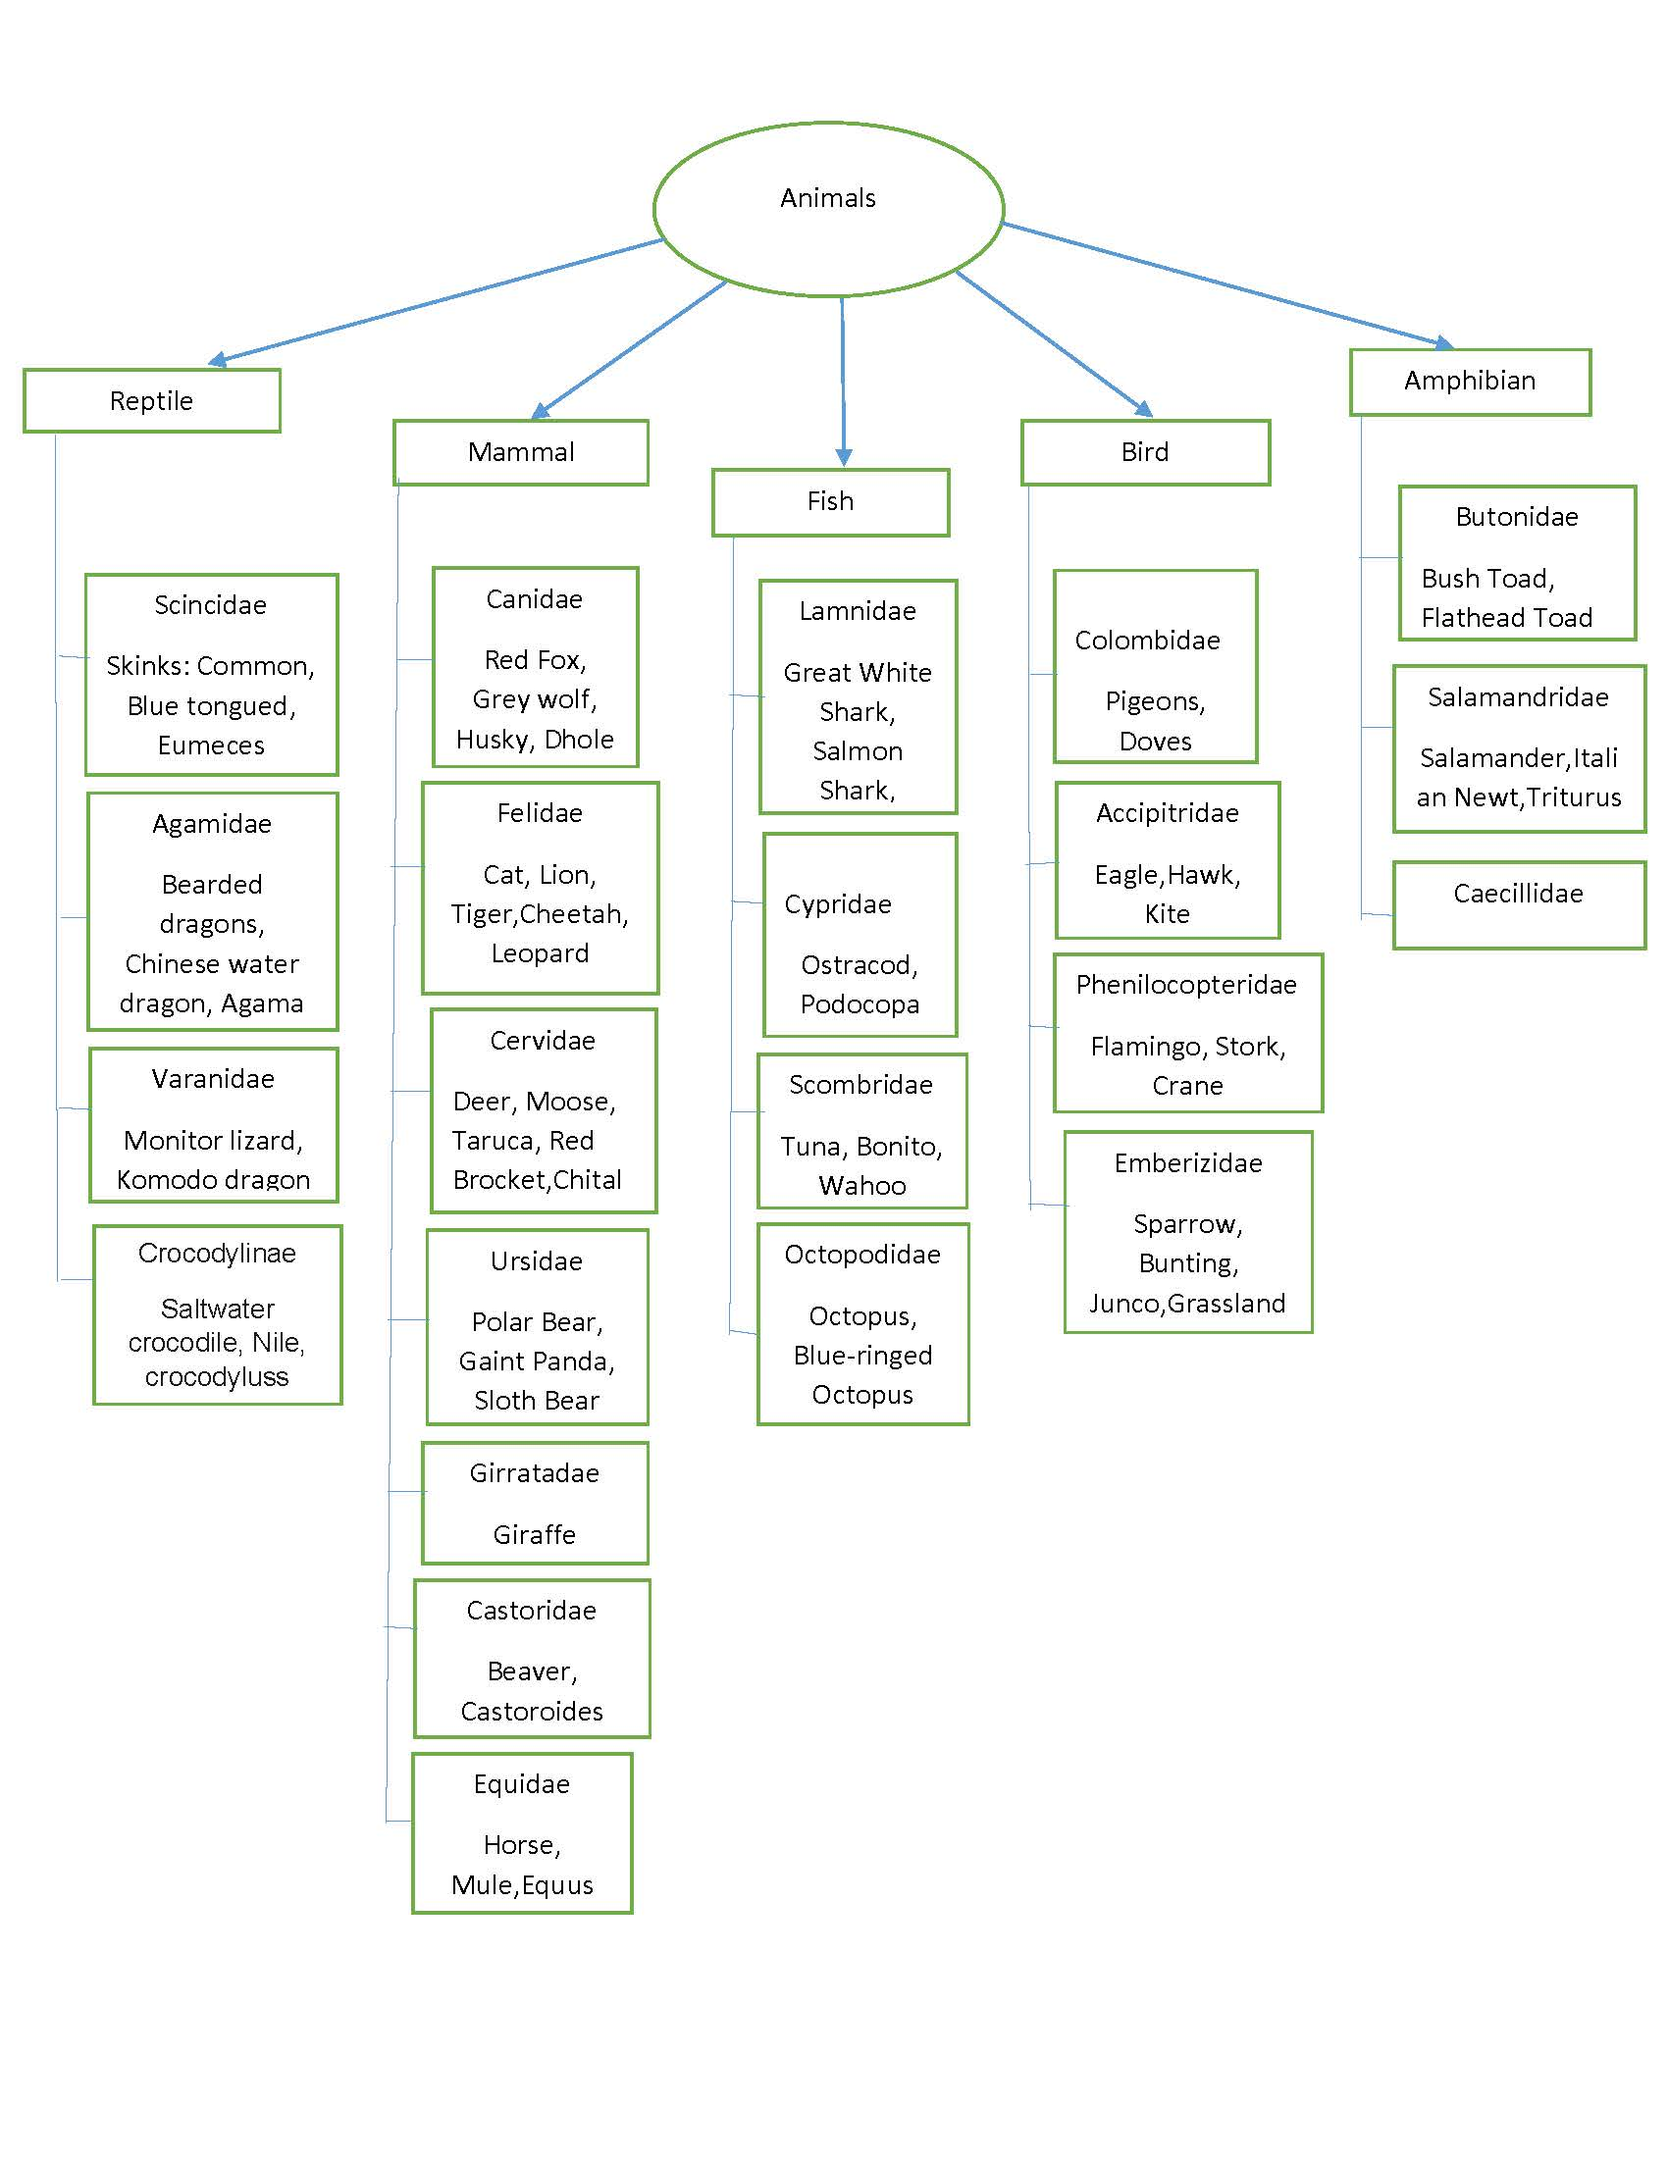

**RULES**

rule0::if Var_animal has 'a nervous system'

or

Var_animal has blood

then

Var_animal isa animal.

rule1::if Var_animal isa animal and

Var_animal has hair

or

Var_animal does 'give milk'

then

Var_animal isa mammal.

rule2::if Var_animal isa animal and

Var_animal has feathers

or

Var_animal does fly and

Var_animal does 'lay eggs'

then

Var_animal isa bird.

rule3::if Var_animal isa animal and

Var_animal has 'three chambered heart'

or

Var_animal does 'live in water and on land'

then

Var_animal isa amphibian.

rule4::if Var_animal isa animal and

Var_animal has 'fins'

or

Var_animal does 'swims'

then

Var_animal isa fish.

rule5::if Var_animal isa animal and

Var_animal has 'scales'

and

Var_animal has 'cold-blood'

then

Var_animal isa reptile .

rule6::if Var_animal isa mammal and

(Var_animal does 'eat meat'

or

Var_animal has 'pointed teeth' and

Var_animal has claws and

Var_animal has 'forward pointing eyes')

then

Var_animal isa carnivore.

rule7::if Var_animal isa animal and

Var_animal does 'eat grass'

or

Var_animal has 'flat molar teeths'

then

Var_animal isa herbivore.

rule8::if Var_animal isa animal and

Var_animal isa carnivore and

Var_animal isa herbivore

then

Var_animal isa omnivore.

rule9::if Var_animal isa animal and

Var_animal isa mammal and

Var_animal isa carnivore and

Var_animal does 'barks'

or

Var_animal does 'howls'

then

Var_animal isa canidae.

rule10::if Var_animal isa animal and

Var_animal isa mammal and

Var_animal has 'tail'

and

Var_animal has 'fur'

then

Var_animal isa felidae.

rule11::if Var_animal isa animal and

Var_animal isa reptile and

Var_animal has 'a long and tapering tail'

or

Var_animal has 'weak legs'

then

Var_animal isa scincidae.

rule12::if Var_animal isa animal and

Var_animal isa reptile and

Var_animal has 'strong legs'

or

Var_animal does 'shows limited change of color'

then

Var_animal isa agamidae.

rule13::if Var_animal isa animal and

Var_animal isa reptile and

Var_animal isa carnivore and

Var_animal has 'high stamina'

then

Var_animal isa varanidae.

rule14::if Var_animal isa animal and

Var_animal isa mammal and

Var_animal isa herbivore and

Var_animal has 'two toes on their feet'

then

Var_animal isa cervidae.

rule15::if Var_animal isa animal and

Var_animal isa mammal and

Var_animal does 'socialize during mating season'

or

Var_animal has 'large claws and long rough fur'

then

Var_animal isa ursidae.

rule16::if Var_animal isa animal and

Var_animal isa mammal and

Var_animal isa herbivore and

Var_animal has 'long neck'

then

Var_animal isa girrafedae.

rule17::if Var_animal isa animal and

Var_animal isa mammal and

Var_animal isa herbivore and

Var_animal does 'is more agile in water '

or

Var_animal has 'stocky bodies with short limbs'

then

Var_animal isa castoridae.

rule18::if Var_animal isa animal and

Var_animal isa mammal and

Var_animal has 'a single toe '

or

Var_animal has 'high crowned teeth'

then

Var_animal isa equidae.

rule19::if Var_animal isa animal and

Var_animal isa fish and

Var_animal isa carnivore and

Var_animal has 'pointed snout'

and

Var_animal has 'large gill openings'

then

Var_animal isa lamnidae.

rule20::if Var_animal isa animal and

Var_animal isa fish and

Var_animal does 'is found in freshwater '

or

Var_animal has 'toothless jaw'

then

Var_animal isa cypridae.

rule21::if Var_animal isa animal and

Var_animal isa fish and

Var_animal has 'snakelike body '

then

Var_animal isa anguillidae.

rule22::if Var_animal isa animal and

Var_animal isa fish and

Var_animal has 'four pair of arms '

then

Var_animal isa octopodidae.

rule23::if Var_animal isa animal and

Var_animal isa fish and

Var_animal does 'is partially endothermic '

then

Var_animal isa scombridae.

rule24::if Var_animal isa animal and

Var_animal isa bird and

Var_animal does 'produces crop milk '

or

Var_animal has 'short neck and slender bills'

then

Var_animal isa columbidae.

rule25::if Var_animal isa animal and

Var_animal isa bird and

Var_animal isa carnivore and

Var_animal has 'strongly hooked bills'

then

Var_animal isa accipitridae.

rule26::if Var_animal isa animal and

Var_animal isa bird and

Var_animal has 'long legs'

and

Var_animal does 'use beak upside down'

then

Var_animal isa phoenicopteridae.

rule27::if Var_animal isa animal and

Var_animal isa bird and

Var_animal isa herbivore and

Var_animal has 'has nine-primary feathers '

then

Var_animal isa emberizidae.

rule28::if Var_animal isa animal and

Var_animal isa amphibian and

Var_animal has 'rough bumpy skin '

and

Var_animal has 'squat body with short legs'

then

Var_animal isa bufonidae.

rule29::if Var_animal isa animal and

Var_animal isa amphibian and

Var_animal has ' four toes on forelimbs '

and

Var_animal has 'no rib'

then

Var_animal isa salamandridae.

rule30::if Var_animal isa animal and

Var_animal isa amphibian and

Var_animal has 'snakelike body '

then

Var_animal isa caecillidae.